Media Art | Title Sequence - Summative
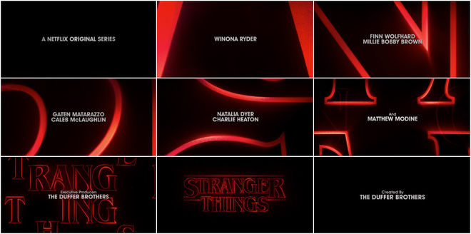 | 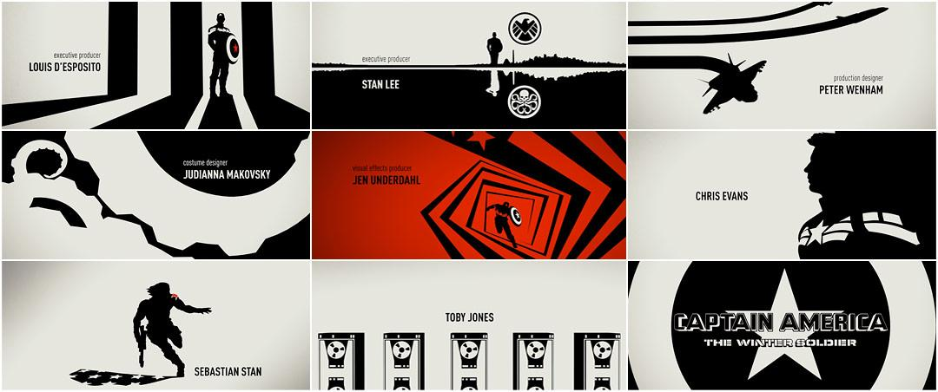
Getting Started
- The title sequence should include a story development.
- You can create a title sequence for one of the following:
  - Choose a favorite poem that you can combine visual imagery with for a title sequence.
  - Lyrics to a song also make a good starting point for imagery in a title sequence - best to choose a local or an indie band and obtain permission to use the song to avoid any copyright issues (do not use a song by a major recording artist for this option).
  - You may also create a title sequence for your favorite short story or a recent news event.
  - Make your own TV show or movie sequence.
  - Another option is to create a title sequence as a demo reel for your work. If you choose this option, you are still required to develop a narrative.

Project Checklist

Slideshow
- Include your planning concepts such as storyboards
- Include 2 examples of title sequences that you’ve learned from
- Discuss how your research has helped you create your title sequence
- Explain your direction with the video / your artistic vision for it
- Include links of tutorials you’ve found and used to create your video

Execution
- Create a 1-2 minute title sequence using creative editing techniques and styles.
- Present a story as a sequence montage.
- Text and images express an idea that prepares the audience for more.
- You have used an appropriate mix of video to still photos for the creative direction (e.g. 50/50 split video and still photos).
- Present main title and author or artist name in the sequence.
- Important words or lines in the development of the poem, song, short story or news event.
- Watch the pacing of your edits because every second counts.
- Demonstrate a knowledge of technical requirements.
- Show a variety of editing techniques from the lists provided (e.g. cutaways, slow motion video, keyframe animation).

Video Editing Techniques / Helpful Tips
- Warp Stabilizer  - Invert Effect - Creative on Video & Text  - Tint Effect - To Create a Gradient Map  - Echo Effect - For Motion Trail  - Strobe Light Effect  - Wave Warp Effect - Glitch Effect (Pin All Edges)  - Keyframe Animation for Motion  - Reverse Speed  - Colour Grading - Adjustment Layer |  |  | - Use Speed Ramping to Create Flow  - Luma Key - Luma Fades for Sky Effects  - Ultra Key - Remove a Colour & Blend  - Transform Effect  - Split Screen  - Stack and Offset Videos  - Gaussian Blur with Opacity Mask  - Crop Effect for Split Screen  - Slow Motion Video  - Warp Stabilizer | - Invert Effect - Creative on Video & Text  - Tint Effect - To Create a Gradient Map  - Echo Effect - For Motion Trail  - Strobe Light Effect  - Wave Warp Effect - Glitch Effect (Pin All Edges)  - Keyframe Animation for Motion  - Reverse Speed

